CAMPUS COUPON SYSTEM
Complete UML and Database Design Activities — Steps 1–14

Part 1: Develop the Use Case Diagram

Step 1: Identify the Actors
Actor | What does this actor need to do?
CUT Student | Log in, view events, RSVP, view wallet and transaction history, and use eligible rewards/coupons.
Event Administrator | Create, update and publish events; view RSVP lists; verify attendance; and manage attendance-related actions.
Cafeteria Staff | Accept valid coupon/reward redemptions and support redemption records within the defined process.
Project Team / IT Support | Develop, test, maintain, integrate, troubleshoot and support the system.
CUT Management / Project Sponsor | Provide governance and oversight of project objectives, participation outcomes and reward policies.

Step 2: Identify the Use Cases
Actor | Use Case
CUT Student | Log in
CUT Student | View Events
CUT Student | RSVP for Event
CUT Student | View Reward Wallet
CUT Student | View Transaction History
CUT Student | Redeem Reward / Coupon
Event Administrator | Create / Update / Publish Event
Event Administrator | View RSVP List
Event Administrator | Verify Attendance
Event Administrator | Manage Attendance Actions
Cafeteria Staff | Accept Valid Redemption
Project Team / IT Support | Test / Maintain System

Step 3: Understand Use Case Relationships
Association: a solid line shows that an actor interacts with a use case.
<<include>>: use only when the included behaviour is always required by the base use case.
<<extend>>: use for conditional or optional behaviour. The attendance reward is conditional on verified attendance.

Step 4: Draw the Use Case Diagram
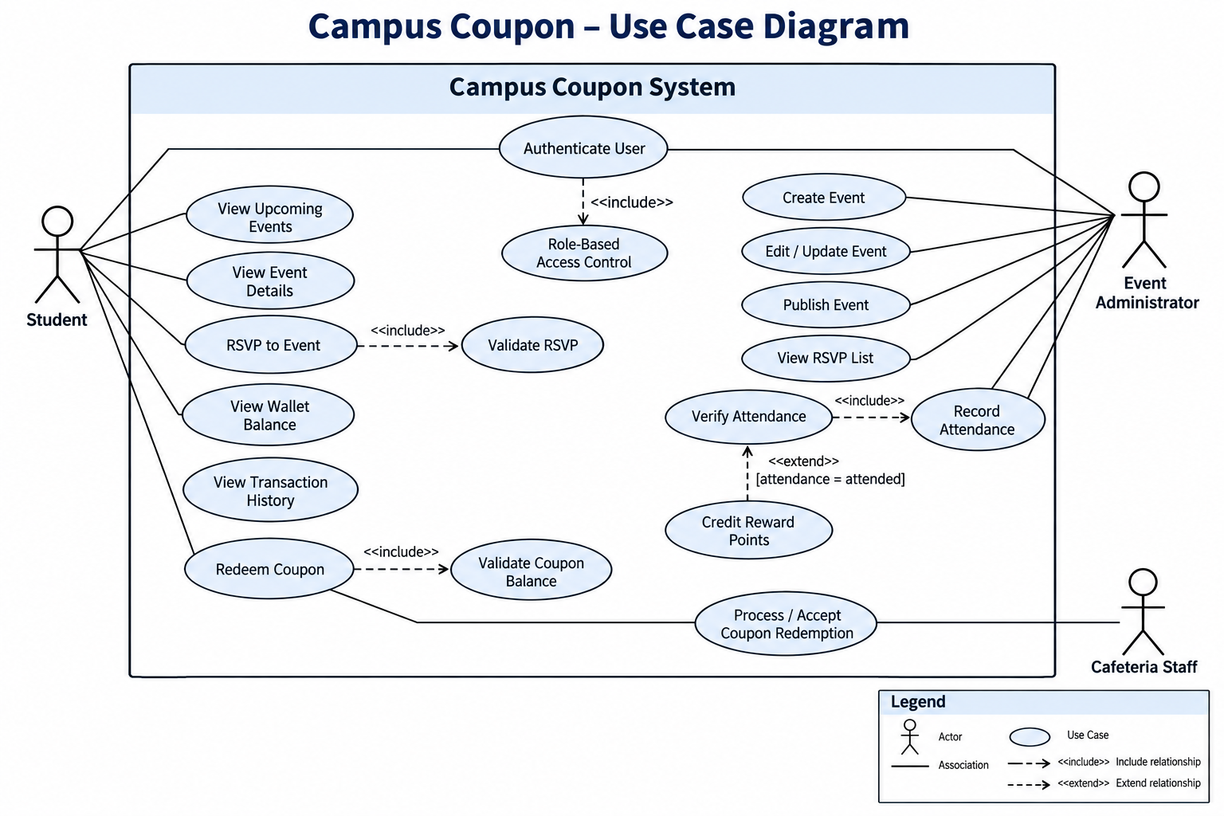
Figure 1: Campus Coupon – Use Case Diagram

Part 2: Develop the Sequence Diagrams

Step 5: Select Important Processes
Two important processes were selected: a student process using the Flutter mobile application and an administrator process using the ASP.NET web application. Both interact with the ASP.NET API and Supabase where required.

Step 6: Identify the Participants
Process | Participant | Role
Student RSVP | Student | Starts the student event interaction.
Student RSVP | Flutter Mobile App | Captures the student action and presents results.
Student RSVP | ASP.NET API | Processes the RSVP request.
Student RSVP | Supabase | Stores/retrieves shared event and RSVP data.
Attendance Verification | Event Administrator | Reviews RSVP students and approves attendance.
Attendance Verification | ASP.NET Web App | Captures administrator actions.
Attendance Verification | ASP.NET API | Processes attendance and reward updates.
Attendance Verification | Supabase | Stores attendance and reward information.

Step 7: Draw the Sequence Diagrams
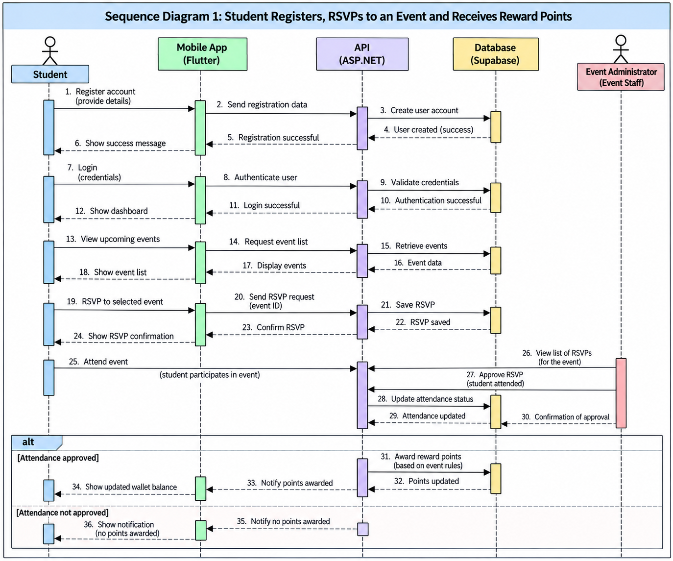
Figure 2: Sequence Diagram 1
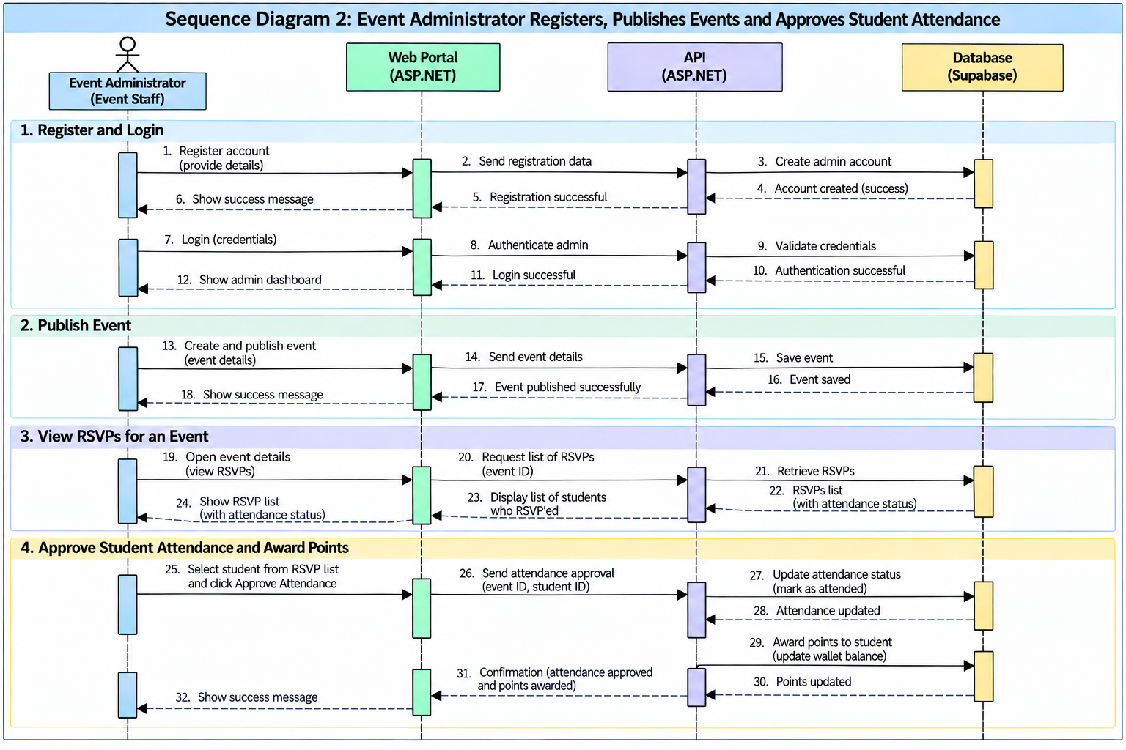
Figure 3: Sequence Diagram 2

Step 8: Check the Sequence Diagrams Against the Use Case
Use Case | Sequence Diagram | System Interaction
RSVP for Event | Student RSVP sequence | Student → Flutter → ASP.NET API → Supabase
Verify Attendance | Administrator attendance sequence | Event Administrator → ASP.NET Web App → ASP.NET API → Supabase
View Events | Student RSVP sequence | Student → Flutter → ASP.NET API → Supabase
Redeem Reward / Coupon | Student reward/redemption process | Student → Flutter → ASP.NET API → Supabase

Part 3: Develop the Database Design
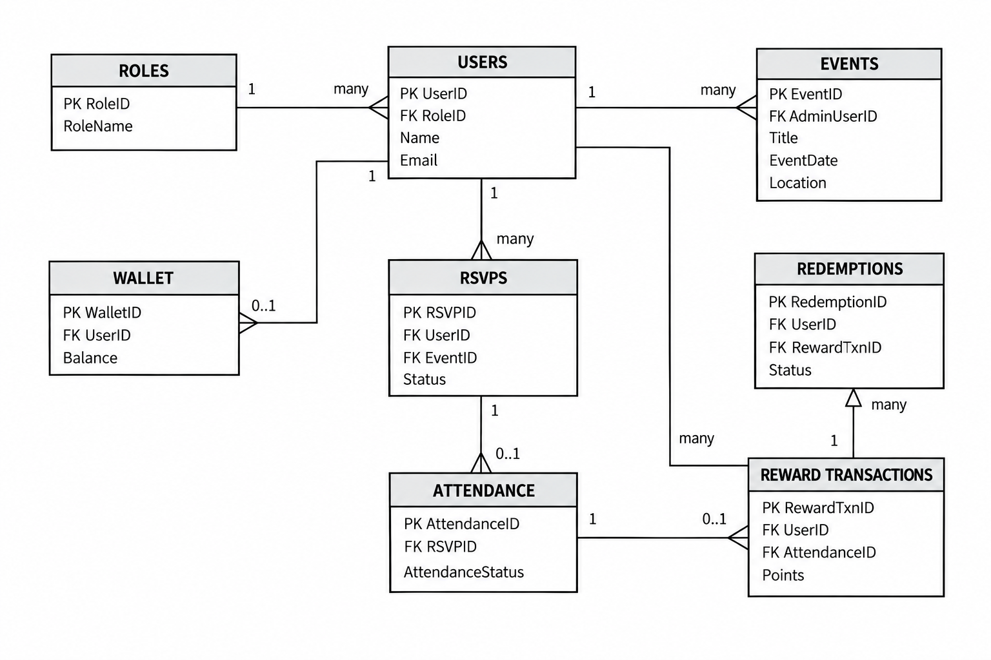
Figure 4: Campus Coupon System – Entity Relationship Diagram

Step 14: Check Alignment Across the Designs
Requirement | Use Case Diagram | Sequence Diagram | ERD
Student views events and RSVPs | View Events, RSVP for Event | Student → Flutter → ASP.NET API → Supabase | Events, Users, RSVPs
Administrator creates/publishes events | Create / Update / Publish Event | Event Administrator → ASP.NET Web App → ASP.NET API → Supabase | Users, Events
Administrator views RSVP list | View RSVP List | Event Administrator → ASP.NET Web App → ASP.NET API → Supabase | RSVPs, Events, Users
Administrator verifies attendance | Verify Attendance, Manage Attendance Actions | Event Administrator → ASP.NET Web App → ASP.NET API → Supabase | Attendance, RSVPs
Reward points are credited after qualifying attendance | Attendance/reward functions | ASP.NET API → Supabase after attendance verification | Reward Transactions, Wallet, Attendance
Student redeems a valid reward/coupon | Redeem Reward / Coupon | Student → Flutter → ASP.NET API → Supabase | Redemptions, Wallet, Reward Transactions

